Malta Access To Renew Dues & Get Information!
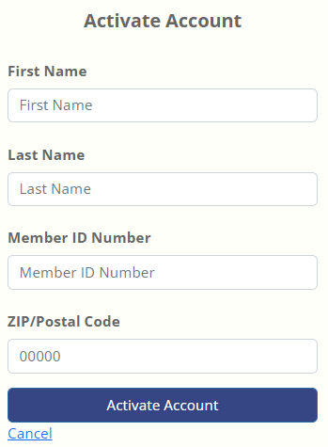
Go to https://malta.vfwauxiliary.org
If you are new to the site, click – “Activate Account”

Enter First Name, Last Name, Member ID # & Zip code
Click Activate Account
You’ll be asked to create a password.

Username is your Member ID Number: __________________________________
Password (you create): _______________________________________________

Membership Dashboard
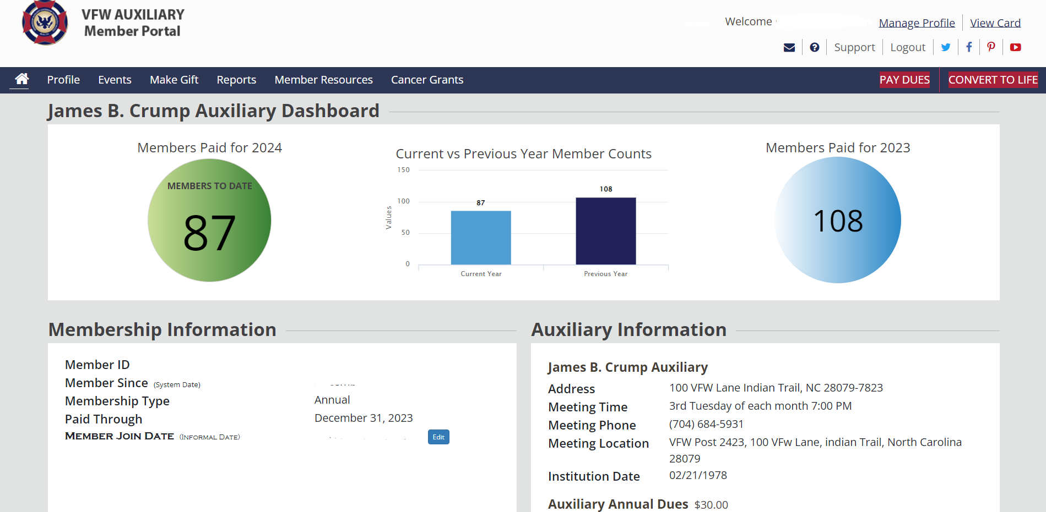
You can renew Annual Dues or Convert to Lifetime Membership – (Upper right corner)
By clicking on either one of those highlighted in red it will give you the amount with the option to pay via Discover, Visa, Mastercard or Amex.
In the navy blue bar are words/ tabs, click the names of each (“Member Resources” or “Cancer Grants”) to view that information.

